**Pixel Samurai**

A challenging 2D action platformer built in Unity where players control a skilled samurai warrior battling through dangerous environments, defeating enemies, confronting powerful bosses, and mastering combat techniques.

# 📌 Technical Overview

* **Unity Version**: Unity 6000.0.42f1
* **Target Platform**: Windows

# 👨‍💻 Team Members

* Nguyễn Quang Sơn
* Võ Lê Đức Anh
* Phan Đức Hậu
* Nguyễn Minh Thành

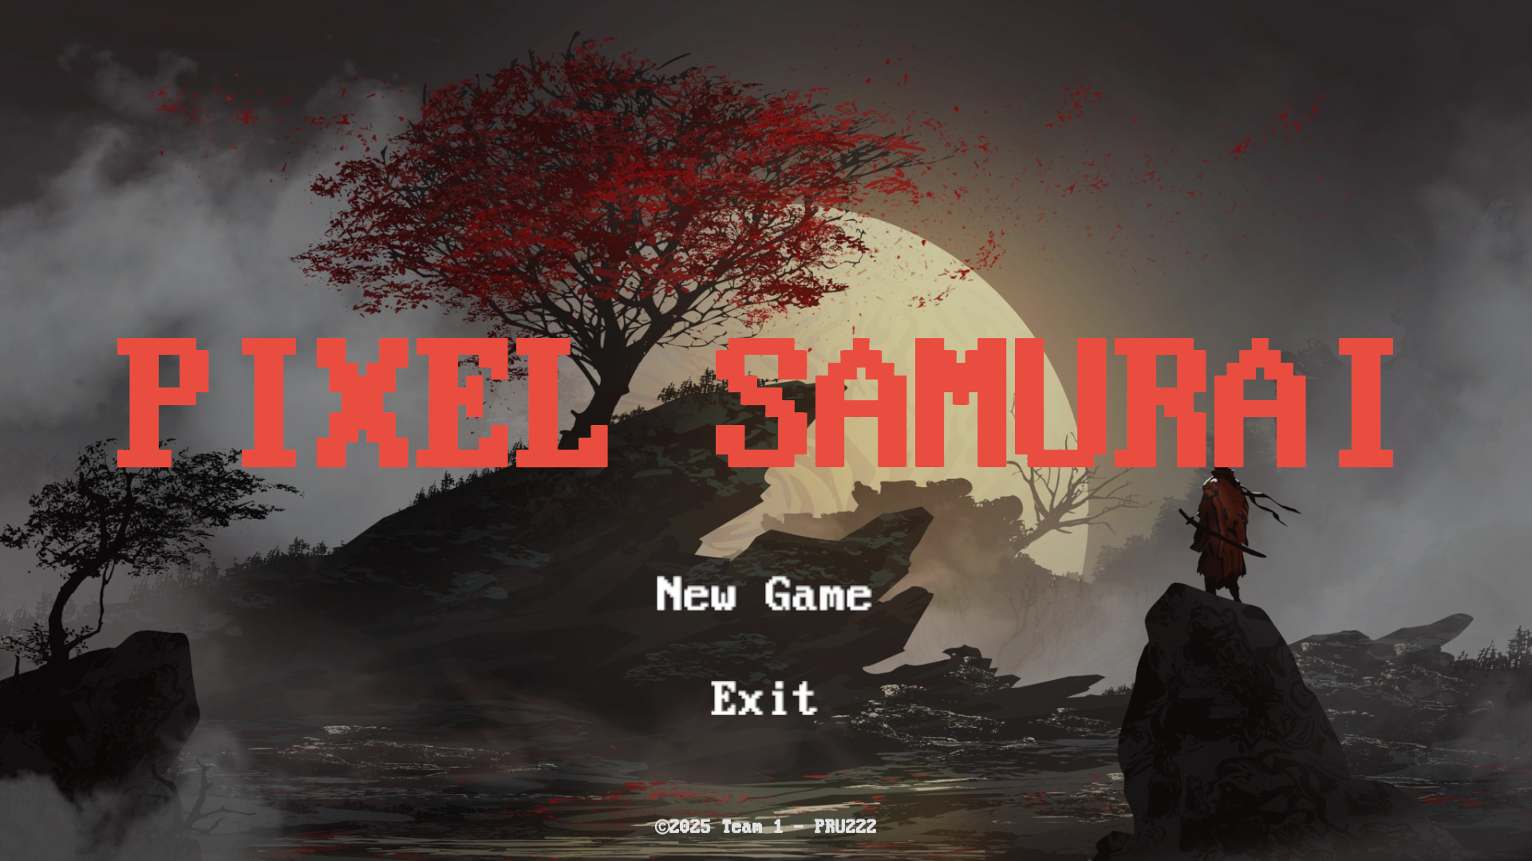

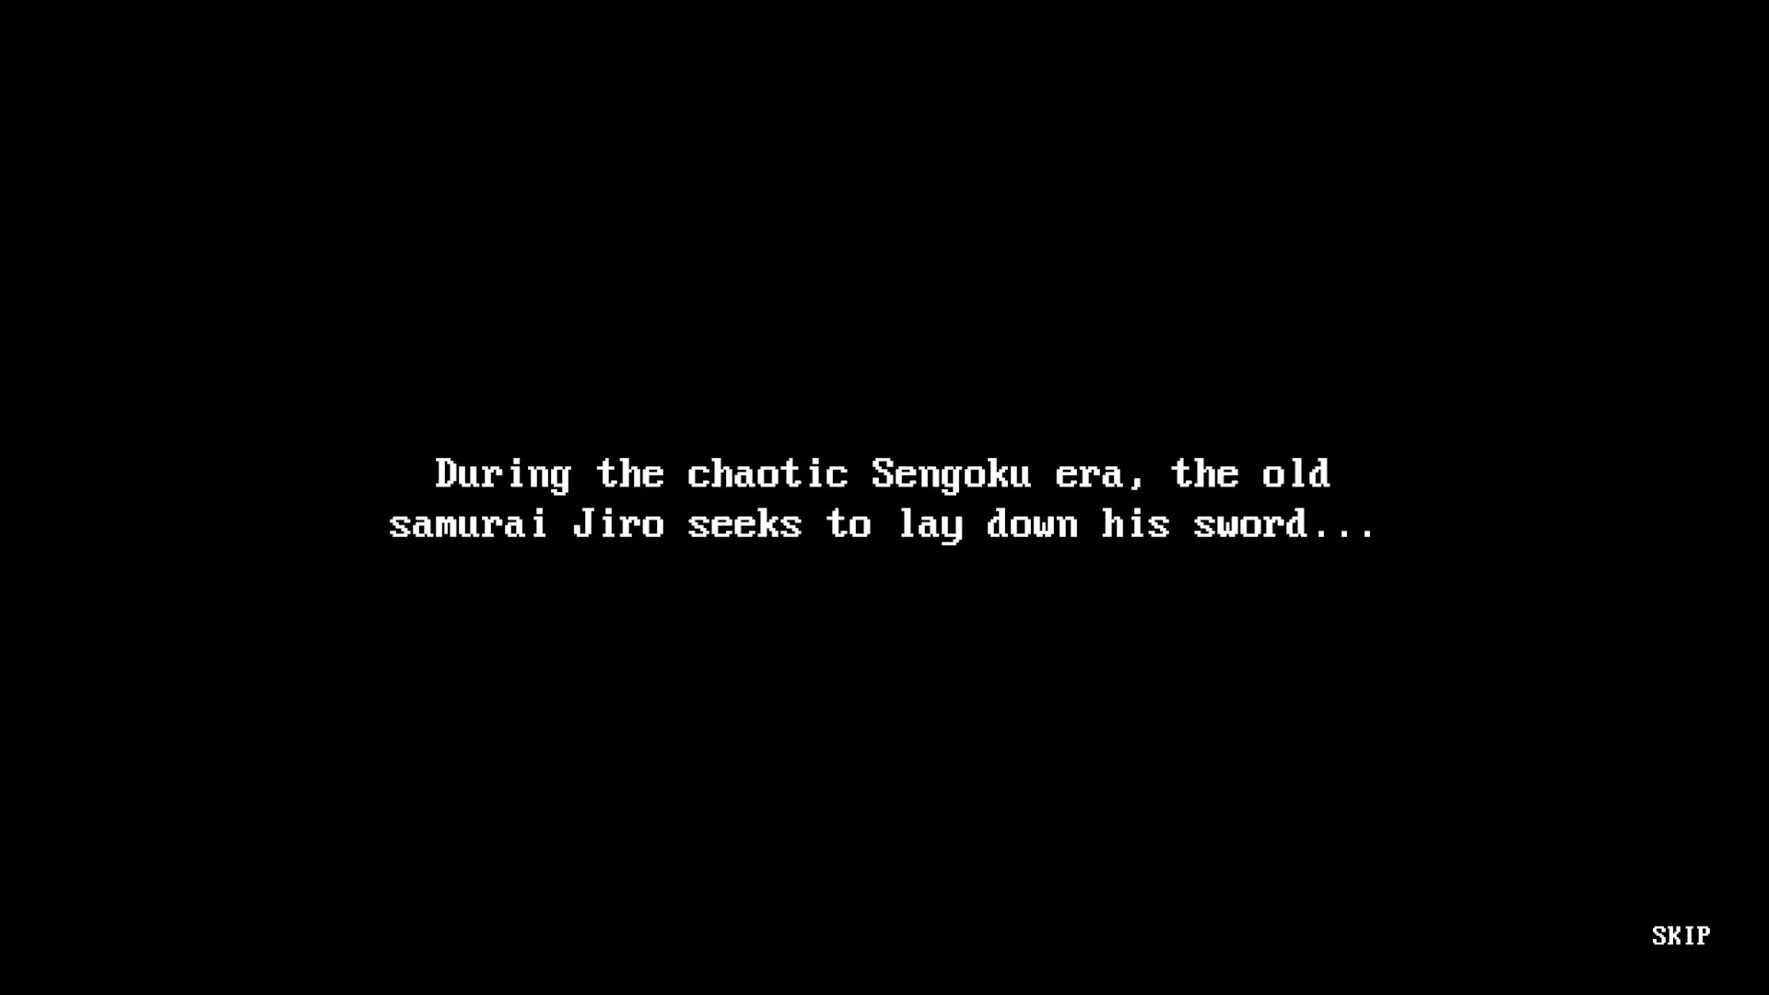

# ⚙️ Core Features

## 🎮 Player Mechanics

* **Fluid Movement System**
  + Precise platforming with wall jumps, ledge climbing, dashing
  + Double jump for advanced mobility
  + Wall sliding for vertical navigation
* **Dynamic Combat System**
  + Fast-paced melee with combos
  + Timing-based attacks & strategic positioning
  + Unique enemy attack patterns
* **After-Image Effect**
  + Dash leaves behind motion trail
  + Dynamic particle systems for immersion
* **Healing System**
  + Limited healing charges
  + Strategic vulnerability during healing
  + Charges restored by defeating enemies

## 

## 🧠 State-Based AI System

* **Finite State Machine Architecture**
  + Modular enemy AI with multiple states
* **Enemy Variety**
  + Unique behaviors and attack patterns
* **Patrolling System**
  + Enemies patrol and respond to player detection
* **Boss Encounters**
  + Multi-phase battles with special abilities
  + Unique mechanics per boss

## 🩸 Health & Combat Management

* Health bars for both player and enemies
* Knockback when hit
* Stun mechanics for crowd control
* Seamless animation-combat integration

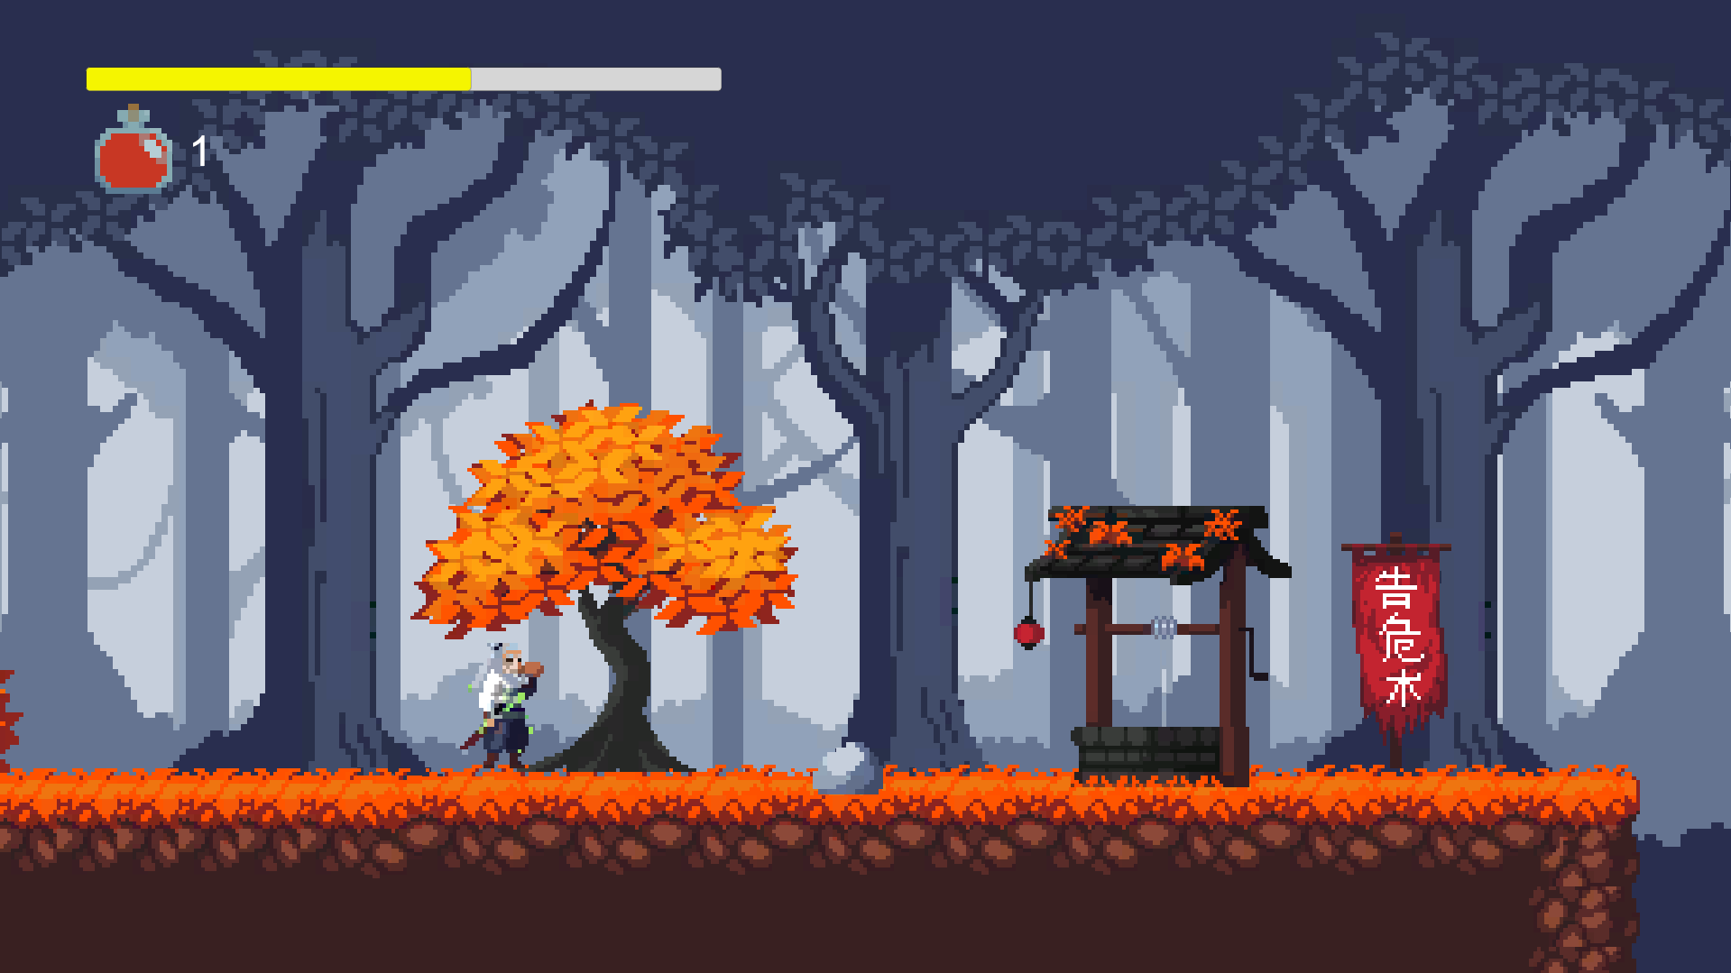

## 👹 Boss Fight System

* 2 Unique bosses with custom mechanics
* Dynamic camera adjustments during fights
* Visual boss health indicators
* Dedicated boss arenas with boundaries
* Scene progression after victory

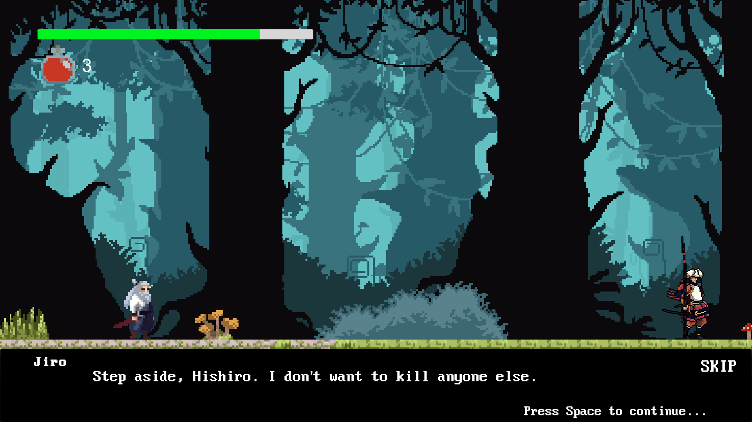

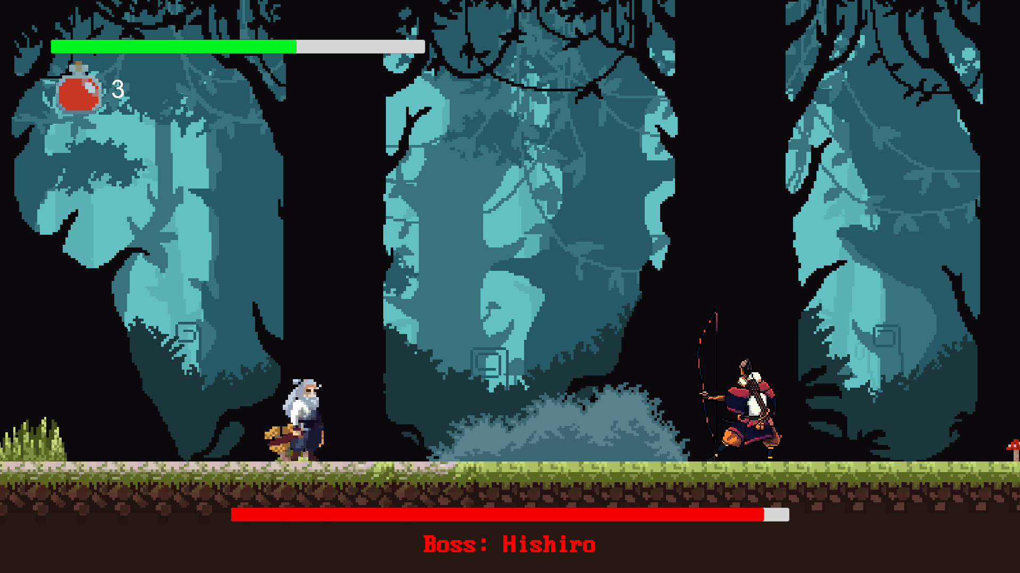

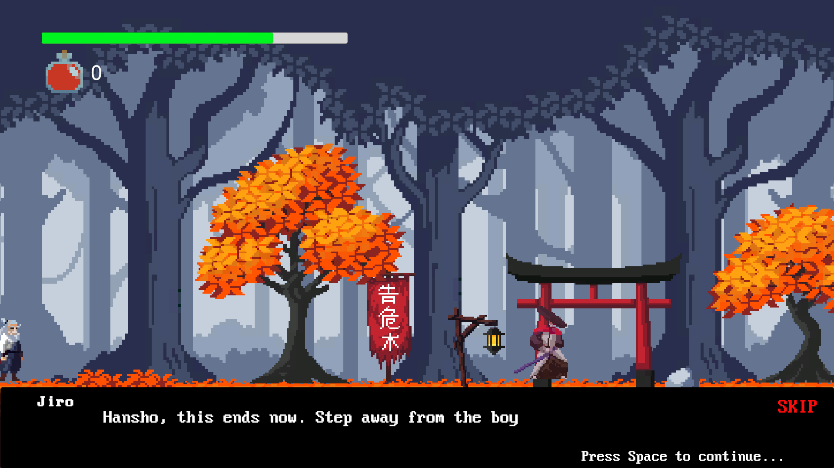

# 🧭 Game States

* **Main Menu**: Start, Options
* **Pause Menu**: Resume or Quit
* **Game Over Screen**: Retry or Exit
* **Scene Management**: Multi-scene progression

# ✨ Visual Effects

* **Death Particles**: Visual effects for deaths
* **Attack Feedback**: Hit confirmation via VFX/SFX
* **Environmental Details**: Responsive backgrounds
* **UI Feedback**: Real-time health, healing indicators

# 🧩 Game Flow

1. Start at Main Menu
2. Platforming and enemy encounters
3. Earn healing charges by defeating enemies
4. Battle boss characters
5. Progress to more challenging scenes
6. Death returns player to checkpoint or restart

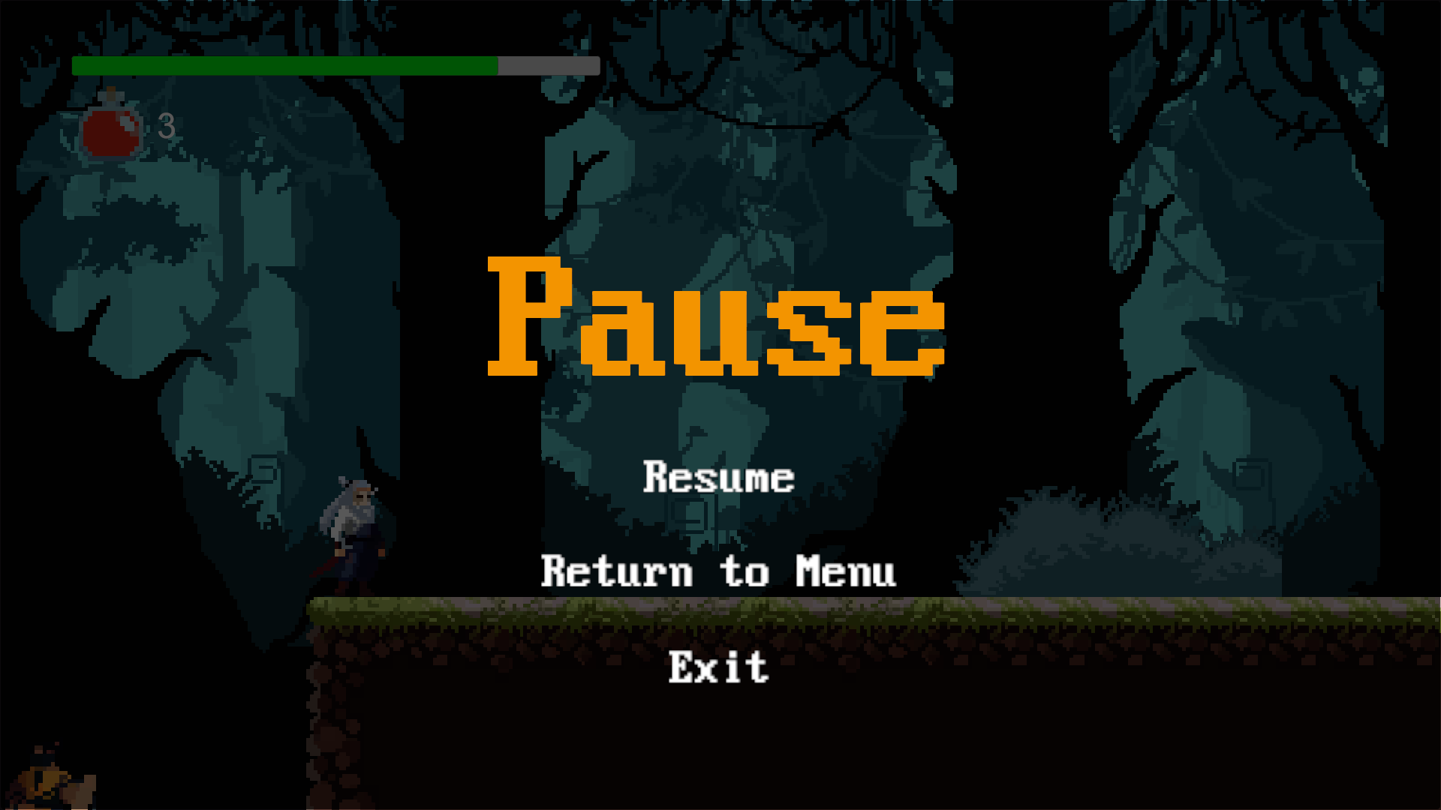

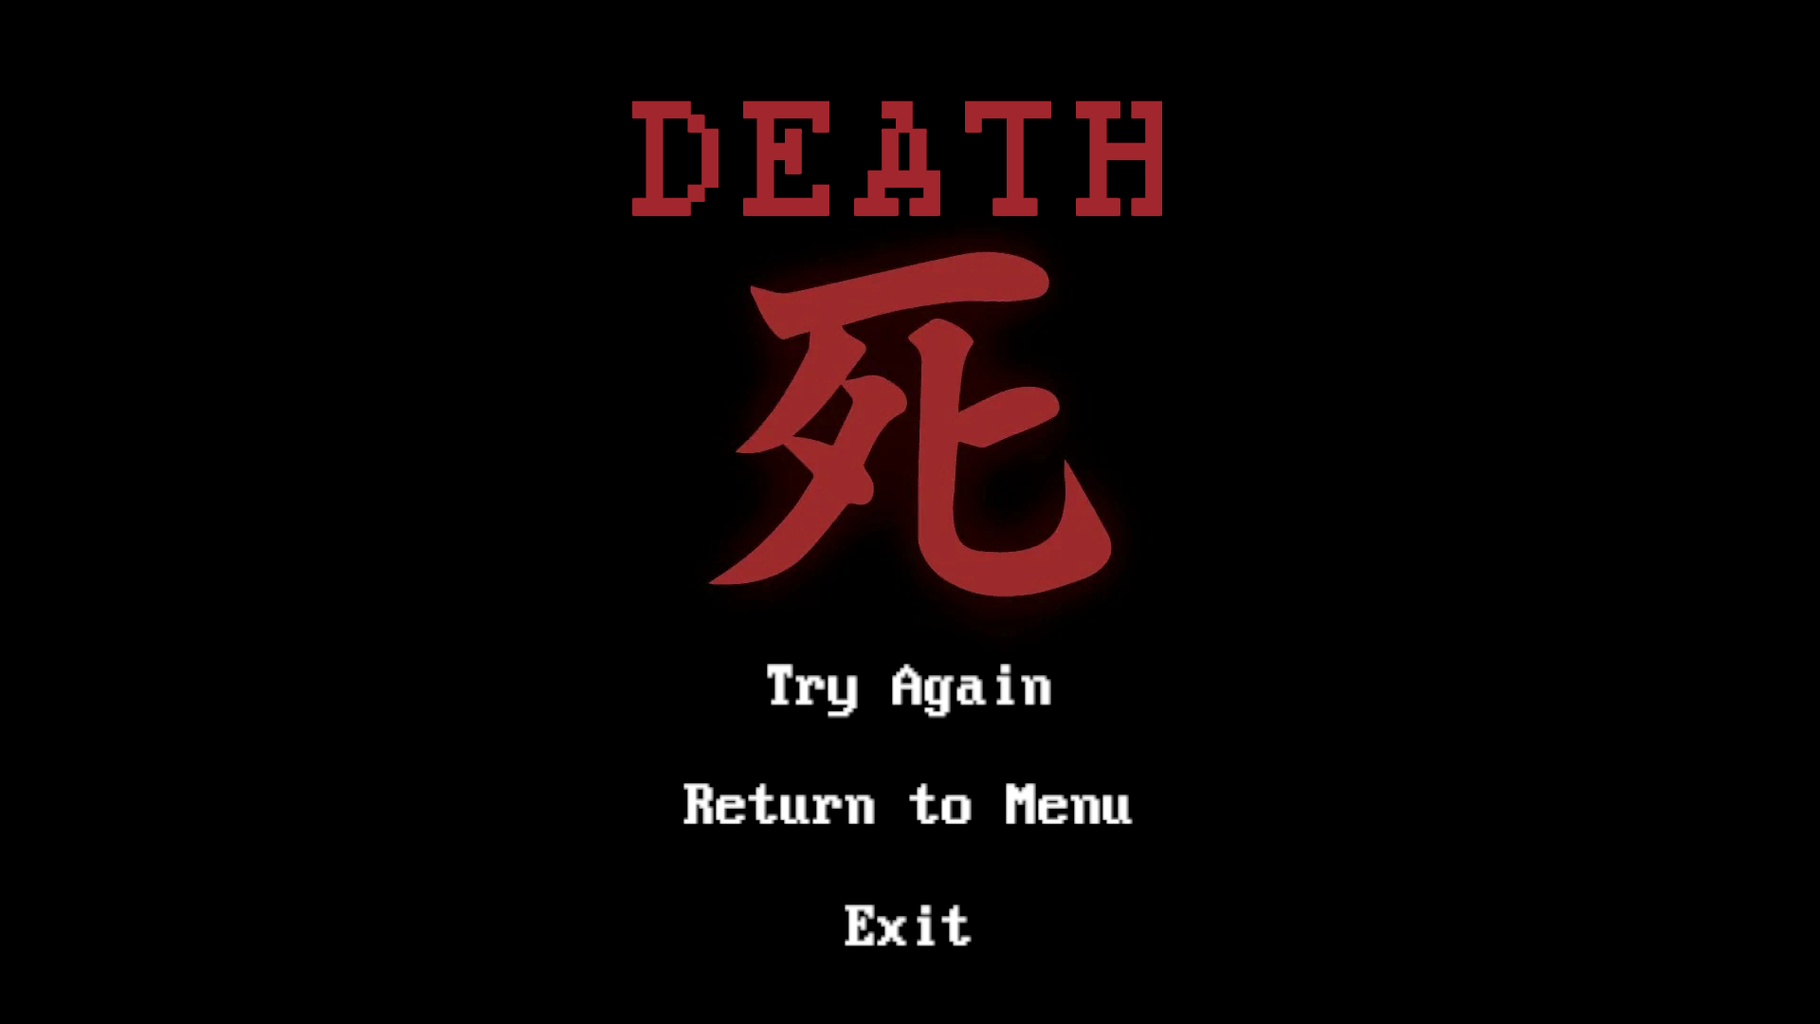

# 🔧 Technical Implementation

* **State Machine AI**: Structured behavior system
* **Object Pooling**: Optimized object reuse
* **Event-Based Health System**: Triggers real-time UI updates
* **Scene Persistence**: Saves player data across scenes
* **Component-Based Architecture**: Clean, modular codebase

# 🧠 Tips for Success

* Master the **dash** to avoid damage and traverse platforms
* Time your **attacks** based on enemy type
* Save **healing charges** for boss fights
* Learn **boss patterns** to counter effectively
* Explore with **wall jumps** and **ledge grabs**
* Refill heals by defeating enemies before key fights